

**Police recover loaded gun during**

**investigation in Lower Roxbury**

**By Andres Picon** Globe Correspondent, November 20, 2018, 10:22 a.m.

**1**

Boston police officers recovered a loaded gun from a Lower Roxbury housing development Sunday night as they were conducting an investigation, police said.



Officers found the loaded .380-caliber handgun in the area of 10 Trotter Court inside the Lenox Street development around 6:18 p.m., Boston police said in a statement Tuesday.

The gun was turned over to the Boston Police Firearms Analysis Unit for processing, police said.

Police declined to give additional information on the nature of the investigation.

[Andres Picon can be reached at andres.picon@globe.com. Follow him on Twitter at](mailto:AndresPiconcanbereachedatandres.picon@globe.com.FollowhimonTwitterat) @andpicon.

**Show comments**

BOSTON GLOBE VIDEO

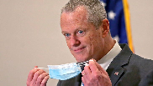

2:23

Baker announces ‘VaxMillions’ l SHARE

Governor Charlie Baker announced residents who are fully vaccinated against COVID-19 will have the chance to win $1 million in a special Lottery sweepstakes. (Photo by Matt Stone/Boston Herald via AP)

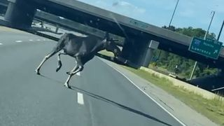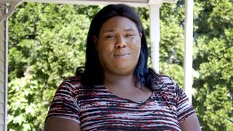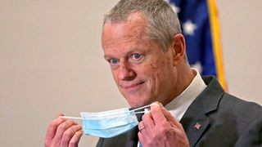

**NOW PLAYING**

**Baker announces**

**Moose spotted**

**What Black**

**‘VaxMillions’ on Route**

**liberation**

**lottery**

**3 in**

**means to**

**program**

**Chelmsford me:**

**Athena Vaughn**

**MOST POPULAR ON BOSTONGLOBE.COM**

1. Life sciences is poised to be Boston’s dominant industry. Has the area become the Silicon Valley of biotech?
2. Some lawmakers want to ban critical race theory in schools. So, what is it?
3. Is there something wrong with the air in South Portland, Maine?
4. How Massachusetts communities are celebrating the state’s first official Juneteenth
5. Coolidge Corner Theatre gets go-ahead for major expansion
6. Message in a bottle, tossed into the sea in Rhode Island, found in Azores
7. The downside of ditching masks: the return of colds, flu
8. Baker announces ‘VaxMillions’ lottery program, offering $1 million cash prizes to boost vaccination rates
9. Biden stays out of our face. Isn’t it great?
10. A power play? Steam plant owner aims to decarbonize downtown with huge building project



**VIEWS FROM OUR COLUMNISTS**

**YVONNE ABRAHAM**

Energy efficiency is a low-hanging fruit to combat climate change. So why can’t everyone get access to it?

**KEVIN CULLEN**

Bill Bratton on American policing and the challenge facing the Boston Police Department

**THOMAS FARRAGHER**

A salute across the ages to an old squad leader

**SHIRLEY LEUNG**

A working mother’s manifesto: Pandemic provides a once-in-a- generation chance to course correct how we work

**JENEÉ OSTERHELDT**

The pride I carry with me: Karim

**ADRIAN WALKER**

‘The best Boston movie no one’s ever seen’: ‘Blue Hill Avenue’ at 20

**MORE ON GLOBE.COM**

# SPONSORED BY: HARVARD PILGRIM HEALTH CARE

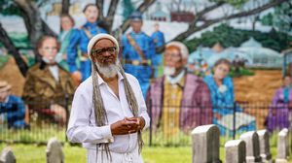

**Parents say they learned these 4 lessons from life in the age of COVID- 19**

How the pandemic shifted New England parents’ perspectives.

# INNOVATION ECONOMY

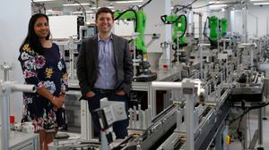**Life sciences is poised to be Boston’s dominant industry. Has the area become the Silicon Valley of biotech?** Since December, you can find six major

indications that Boston is the undisputed

center of the life sciences industry, a place where ideas and products that change — and save — people’s lives around the world originate.

**How Massachusetts communities are celebrating the state’s first official Juneteenth**

For more than a century, Juneteenth was a

Texan holiday, then a Southern holiday, commemorating the anniversary of June 19, 1865, when General Gordon Granger of the Union Army told formerly enslaved people in Galveston they were free. Now it will be celebrated for the first time across the Commonwealth as an official state holiday.

# THE GREAT DIVIDE

**Some lawmakers want to ban critical race theory in schools. So, what is it?** As national debate over race-related

curriculums rages on, here is a lesson on the

subject and the controversy surrounding it.

# GLOBE MAGAZINE

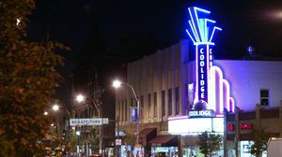

**Is there something wrong with the air in South Portland, Maine?**

Residents have lived near more than 100

massive petroleum storage tanks for decades, never really knowing if they’re breathing in dangerous chemicals. Now they’re fighting to find out.

**Coolidge Corner Theatre gets go- ahead for major expansion**

Brookline officials are reviewing a proposed

expansion of the landmark Art Deco cinema that will add two new screens — and over 200 seats — as well as a larger lobby and third- floor community space, with a catering kitchen and outdoor roof deck.

**The downside of ditching masks: the return of colds, flu**

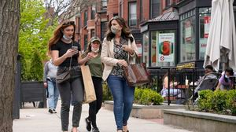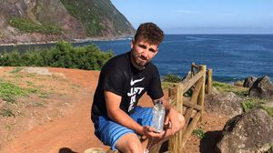

Since the state’s mask mandate was lifted,

face coverings have started to come off — and stay off. But according to infectious diseases doctors, the return of facial freedom might come with some downsides, like a resurgence in cases of the common cold and the flu.

# RI NEWS

**Message in a bottle, tossed into the sea in Rhode Island, found in Azores** The note was written in 2018 by a 13-year-old

who was visiting family in Rhode Island.

**Baker announces ‘VaxMillions’ lottery program, offering $1 million cash prizes to boost vaccination rates**

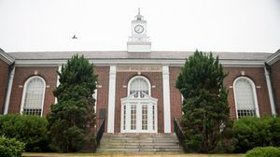

State officials on Tuesday said residents who

are fully vaccinated against COVID-19 will have the chance to win $1 million in a special Lottery sweepstakes.

**UMass Lowell to remain closed Wednesday while investigating ‘cybersecurity incident’**

The University of Massachusetts Lowell was

forced to cancel all in-person and remote classes Tuesday and Wednesday “due to an IT outage,” the university said.



**METRO SPORTS BUSINESS & TECH OPINION VACCINE NEWS & RESOURCES SPOTLIGHT**

WELCOME, JOHN

**TODAY'S PAPER**

**Summer Fitness Challenge Starts Monday**

Sign up now

**MOST READ IN THIS SECTION**

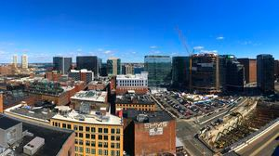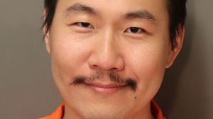

**How Massachusetts communities are celebrating the state’s first official Juneteenth**

**THE GREAT DIVIDE**

**Some lawmakers want to ban critical race theory in schools. So, what is it?**

**GLOBE MAGAZINE**

**Is there something wrong with the air in South Portland, Maine?**

**RI NEWS**

**Message in a bottle, tossed into the sea in Rhode Island, found in Azores**

**The downside of ditching masks: the return of colds, flu**

**Baker announces ‘VaxMillions’ lottery program, offering $1 million cash prizes to boost vaccination rates**

**UMass Lowell to remain closed Wednesday while investigating ‘cybersecurity incident’**

**With housing at center of Boston mayor’s race, labor and developers are organizing to push candidates**

**Documents shed new light on case of MIT grad student accused of murder in Connecticut**



**FOLLOW US**

**SUBSCRIBE NOW**

Digital Access Home Delivery Gift Subscriptions

**MY ACCOUNT**

Log In

Manage My Account Customer Service

**CONTACT**

Help & FAQs Globe Newsroom Advertise

**MORE**

Newsletters / View The EPaper / Order Back Issues /

News In Education / Search The Archives / Privacy Policy / Terms Of Service / Terms Of Purchase /

Work At Boston Globe Media / Do Not Sell My Personal Information

©2021 Boston Globe Media Partners, LLC